What is an HTML File?
- HTML stands for Hyper Text Markup Language
- An HTML file is a text file containing small markup tags
- The markup tags tell the Web browser how to display the page
- An HTML file must have an htm or html file extension
- An HTML file can be created using a simple text editor
If you are running Windows, start Notepad.
Type in the following text:
<html>
<head>
<title>Title of page</title>
</head>
<body>
This is my first homepage. <b>This text is bold</b>
</body>
</html>
Save the file as "mypage.htm".
Start your Internet browser. Select "Open" (or "Open Page") in the File menu of your browser. A dialog box will appear. Select "Browse" (or "Choose File") and locate the HTML file you just created - "mypage.htm" - select it and click "Open". Now you should see an address in the dialog box, for example "C:\MyDocuments\mypage.htm". Click OK, and the browser will display the page.

Example Explained
The first tag in your HTML document is <html>. This tag tells your browser that this is the start of an HTML document. The last tag in your document is </html>. This tag tells your browser that this is the end of the HTML document.
The text between the <head> tag and the </head> tag is header information. Header information is not displayed in the browser window.
The text between the <title> tags is the title of your document. The title is displayed in your browser's caption.
The text between the <body> tags is the text that will be displayed in your browser.
The text between the <b> and </b> tags will be displayed in a bold font.

HTM or HTML Extension?
When you save an HTML file, you can use either the .htm or the .html extension. We have used .htm in our examples. It might be a bad habit inherited from the past when some of the commonly used software only allowed three letter extensions.
With newer software we think it will be perfectly safe to use .html.
HTML documents are text files made up of HTML elements.
HTML elements are defined using HTML tags.

HTML Tags
- HTML tags are used to mark-up HTML elements
- HTML tags are surrounded by the two characters < and >
- The surrounding characters are called angle brackets
- HTML tags normally come in pairs like <b> and </b>
- The first tag in a pair is the start tag, the second tag is the end tag
- The text between the start and end tags is the element content
- HTML tags are not case sensitive, <b> means the same as <B>

HTML Elements
Remember the HTML example from the previous page:
<html>
<head>
<title>Title of page</title>
</head>
<body>
This is my first homepage. <b>This text is bold</b>
</body>
</html>
This is an HTML element:
<b>This text is bold</b>
The HTML element starts with a start tag: <b>
The content of the HTML element is: This text is bold
The HTML element ends with an end tag: </b>
The purpose of the <b> tag is to define an HTML element that should be displayed as bold.
This is also an HTML element:
<body>
This is my first homepage. <b>This text is bold</b>
</body>

This HTML element starts with the start tag <body>, and ends with the end tag </body>.
The purpose of the <body> tag is to define the HTML element that contains the body of the HTML document.

Why do we Use Lowercase Tags?
We have just said that HTML tags are not case sensitive: <B> means the same as <b>. When you surf the Web, you will notice that most tutorials use uppercase HTML tags in their examples. We always use lowercase tags. Why?
If you want to prepare yourself for the next generations of HTML, you should start using lowercase tags. The World Wide Web Consortium (W3C) recommends lowercase tags in their HTML 4 recommendation, and XHTML (the next generation HTML) demands lowercase tags.

Tag Attributes
Tags can have attributes. Attributes can provide additional information about the HTML elements on your page.
This tag defines the body element of your HTML page: <body>. With an added bgcolor attribute, you can tell the browser that the background color of your page should be red, like this: <body bgcolor="red">.
This tag defines an HTML table: <table>. With an added border attribute, you can tell the browser that the table should have no borders: <table border="0">
Attributes always come in name/value pairs like this: name="value".
Attributes are always added to the start tag of an HTML element.
Attribute values should always be enclosed in quotes. Double style quotes are the most common, but single style quotes are also allowed.
In some rare situations, like when the attribute value itself contains quotes, it is necessary to use single quotes:
name='John "ShotGun" Nelson'

There are different tags used for creating different web pages. Tags are explained in details, as follows:

BASIC HTML TAGS

<html> & </html>

It defines an HTML document and it is required to be written in the starting of the HTML document.

<body> & </body>

It defines the body of a HTML document. Any thing written between these two tags will be considered as the main document to be displayed.

<h1> to <h6> & </h1> to </h6>

It defines the headings in different sizes.

<h1> defines the largest heading. <h6> defines the smallest heading.

<p>& </p>

It defines the paragraph. HTML automatically adds an extra blank line before and after a paragraph.

<hr>& </hr>

It defines a horizontal rule.

<br>

It inserts a single line break. It is used when we want to end a line but not when we want to start a new paragraph.

The <br> tag is an empty tag. It has no closing tag.

EXAMPLES ON BASIC HTML TAGS

1. <html> & <body> tags

Text written in notepad:

<html>

<body>

this Is the first web page !

hello world!

</body>

</html>

Browser window:

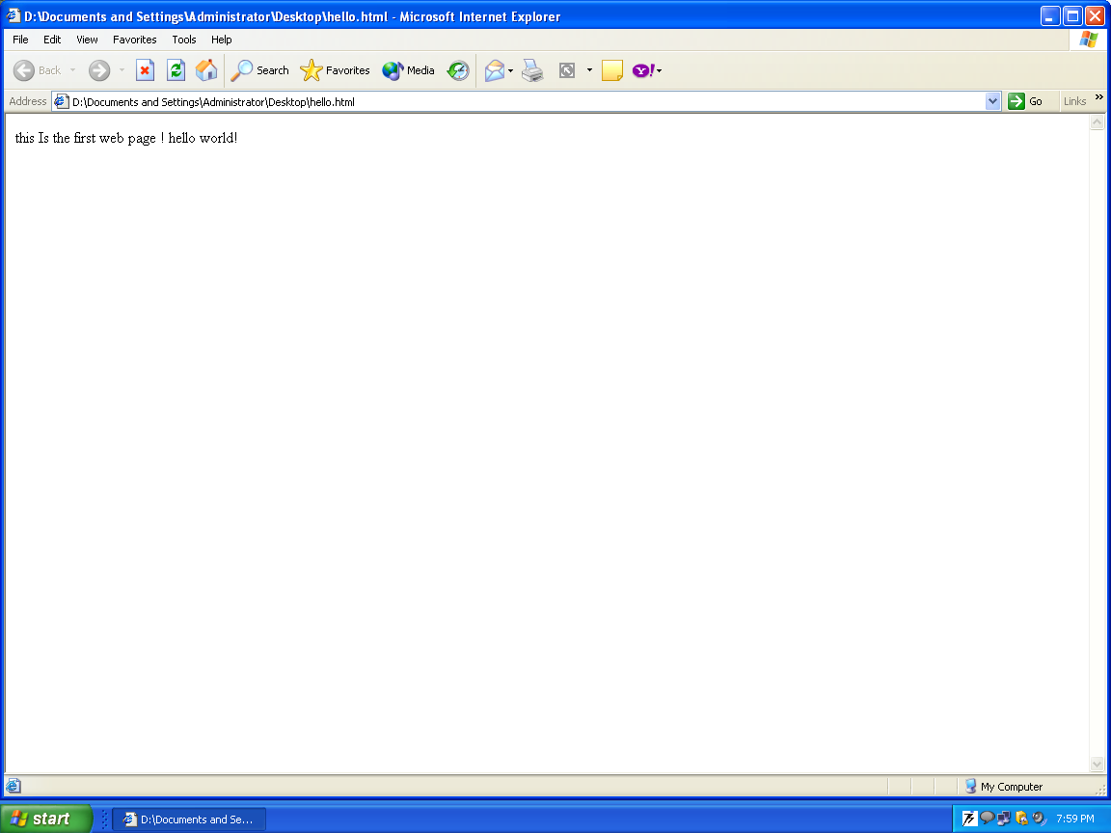

2. <h1> to <h6> & <br> tags

Text written in notepad:

<html>

<body>

<h1> this Is the first web page ! </h1> <br>

<h2> this Is the first web page ! </h2> <br>

<h3> this Is the first web page ! </h3> <br>

<h4> this Is the first web page ! </h4> <br>

<h5> this Is the first web page ! </h5> <br>

<h6> this Is the first web page ! </h6> <br>

</body>

</html>

Browser window:

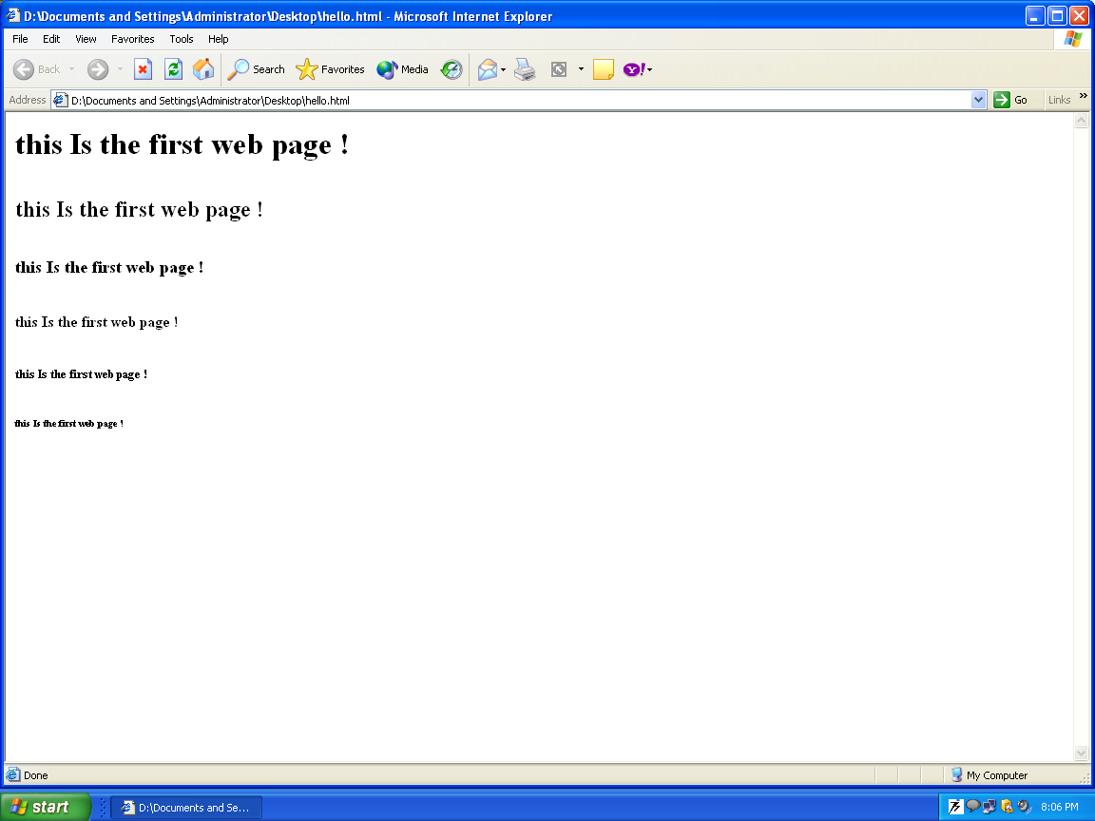

3. <p> tag

Text written in notepad:

<html>

<body>

<p>this is text 1 in a paragraph.

this is text 2 in paragraph.

<p>this is text 3 in paragraph. </p>

<p>Paragraph elements are defined by the p tag.</p>

</body>

</html>

Browser window:

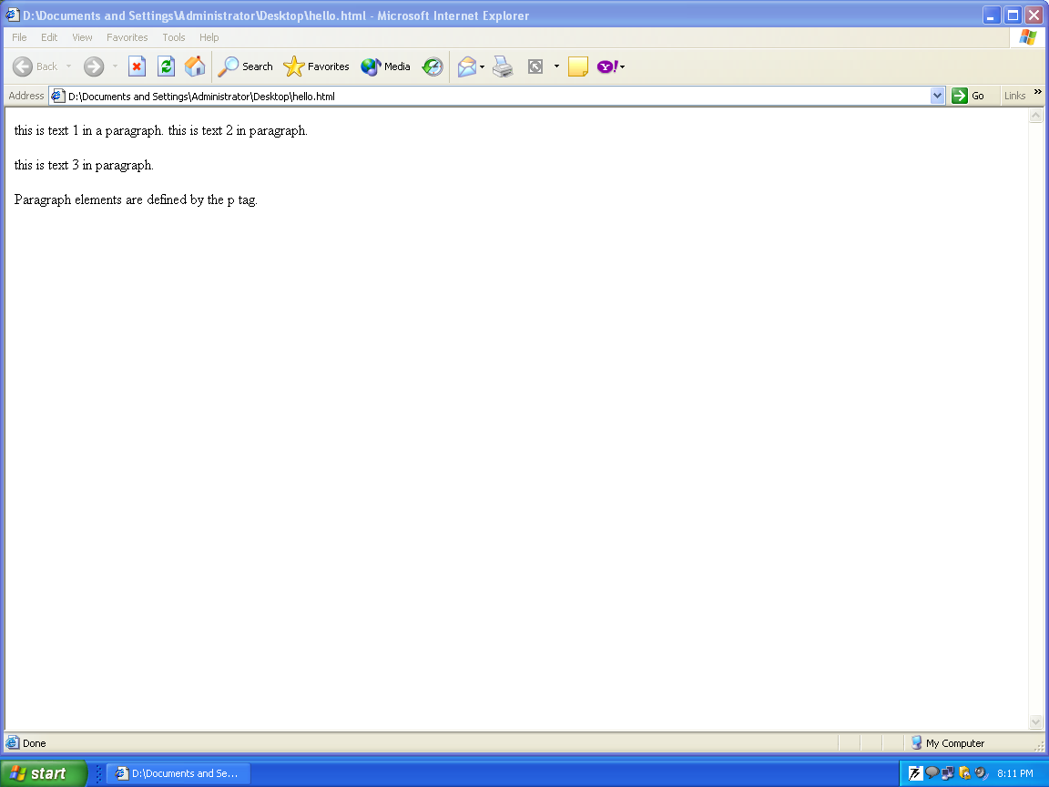

4. <hr> tag

Text written in notepad:

<html>

<body>

<p>this is text 1 in a paragraph.

This is text 2 in paragraph.

<p>this is text 3 in paragraphs. </p>

<hr>

<p>Paragraph elements are defined by the p tag.</p>

Second, third & fourth

</hr>

text after horizontal rule inserted

</body>

</html>

Browser window:

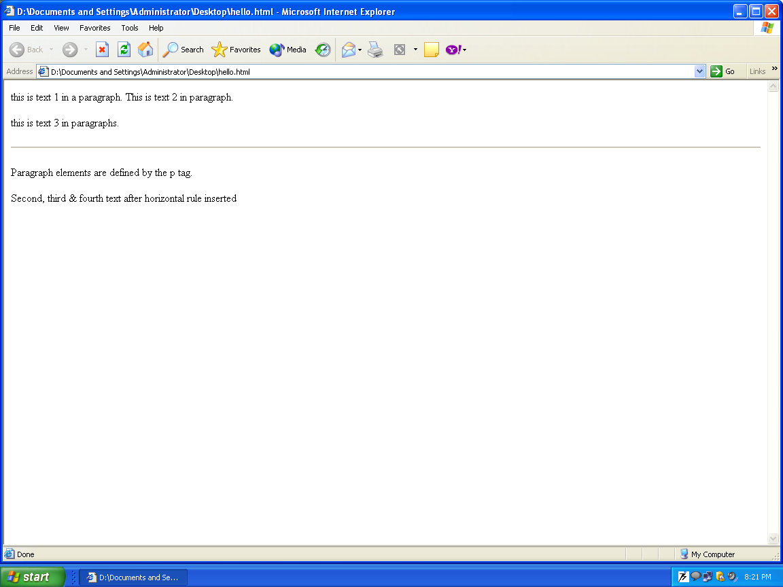

TEXT FORMATTING TAGS

a) <b> & </b>

It defines bold text in a HTML document.

<big> & </big>

It defines bold text in a HTML document.

<em>& </em>

It emphasis the text in a HTML document. .

<i> & </i>

It defines text in italics in a HTML document.

<small> & </small>

It defines small text in a HTML document.

<sub> & </sub>

It defines subscripted text in a HTML document.

<sup> & </sup>

It defines superscripted text in a HTML document.

<font> & </font>

It is used to change the font, color and type of the text in HTML document.

EXAMPLES ON TEXT FORMATTING HTML TAGS

1. All formatting tags except <font> tag

Text written in notepad:

<html>

<body>

<b>This text is bold</b><br>

<strong>

This text is strong

</strong><br>

<big>

This text is big

</big><br>

<em>

This text is emphasized

</em><br>

<i>

This text is italic

</i><br>

<small>

This text is small

</small><br>

This text contains subscript

eg : H <sub>2</sub>0 <br>

This text contains superscript

eg : 0<sup>2-</sup>

</body>

</html>

Browser window:

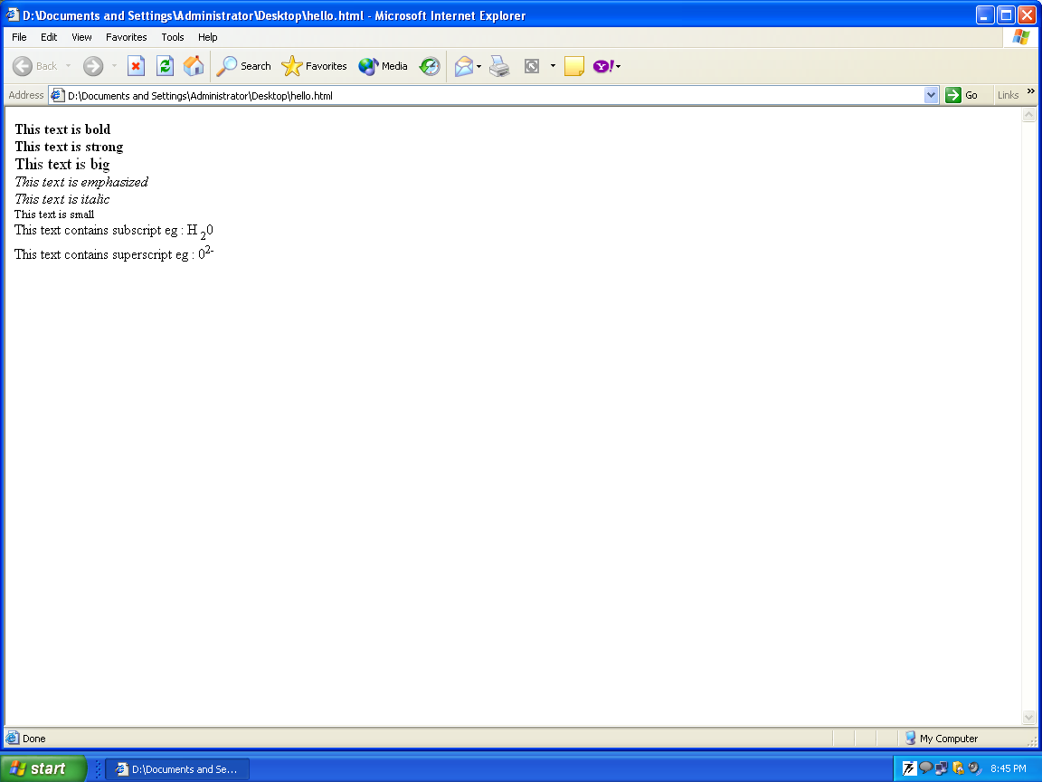

2. <font> tag

There are two methods by which we can format the text in HTML document.

First, by using the font tag and second, by using style attribute an any of the tags used in HTML document.

a) USING <font> TAG

Font tag has different attributes. By using these attributes we can change the color, font and type of the text in the HTML document.

Different attributes used are:

Font Attributes
Attribute = “Value” | Example | Purpose
Size="number" | size="2" | Defines the font size
Size="+number" | size="+1" | Increases the font size
Size="-number" | size="-1" | Decreases the font size
Face="face-name" | face="Times" | Defines the font-name
Color="color-value" | color="#eeff00" | Defines the font color
Color="color-name" | color="red" | Defines the font color

i) How to change font, color and type of the text

Text written in notepad:

<html>

<body>

<p>

<font size="2" face="Verdana" color = "blue">

This is a paragraph.

</font>

</p>

<p>

<font size="3" face="Times" color = "green">

This is another paragraph.

</font>

</body>

Browser window:

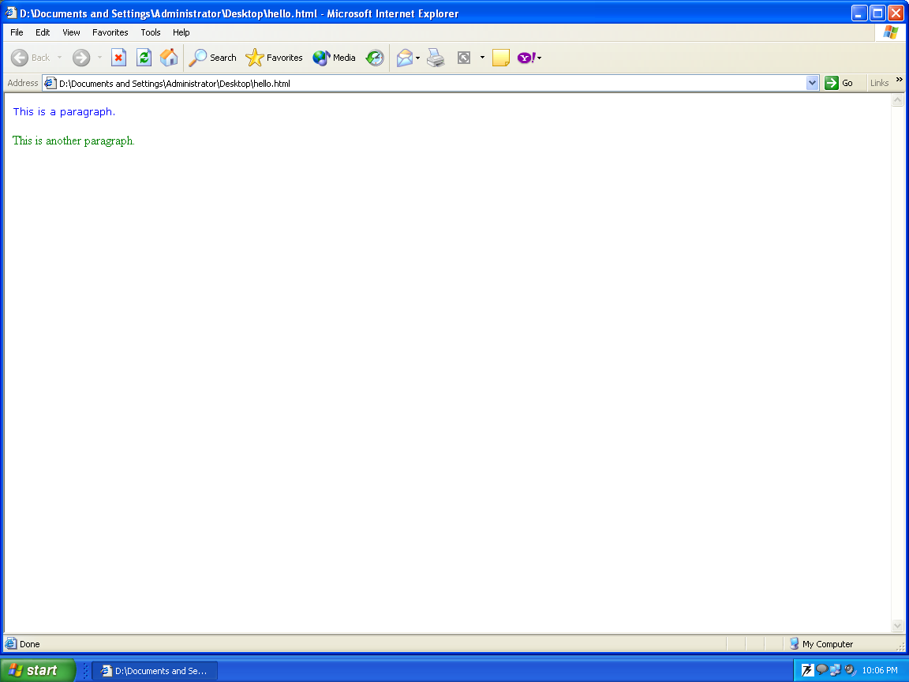

ii) How to change only font of the text

Text written in notepad:

<html>

<body>

<p>

<font size="2" >

This is a paragraph.

</font>

</p>

<p>

<font size="10" >

This is another paragraph.

</font>

</body>

Browser window:

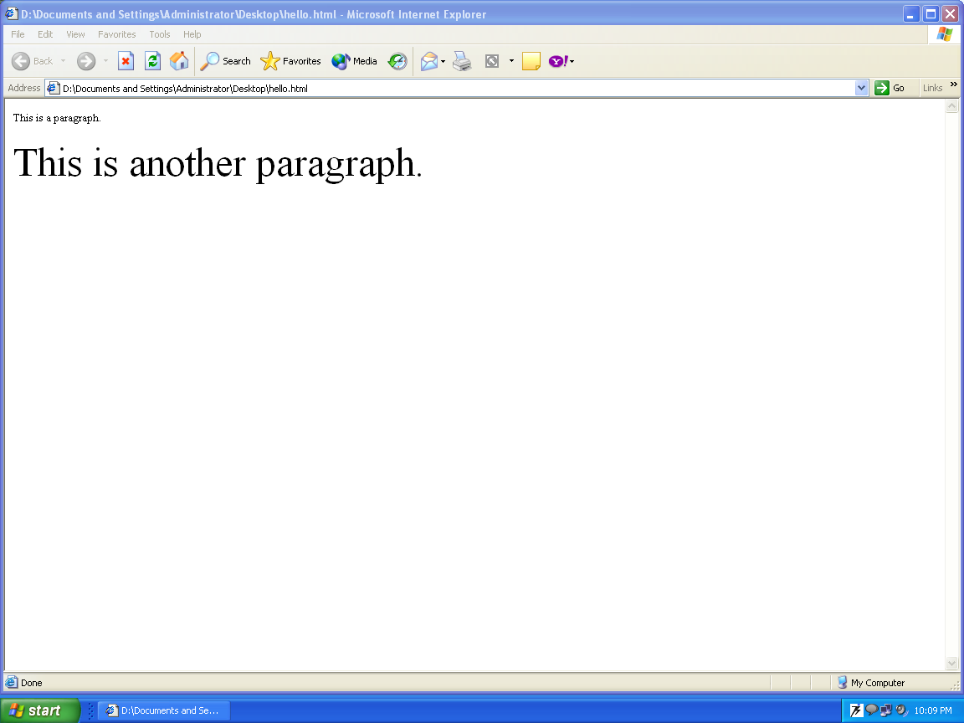

NOTE: Similarly if only color & type of the text needs to be changed then only that attribute is used in the font tag.

b) USING style ATTRIBUTE

style attribute can be used in any tag in order to format the text in the HTML document.

USING style ATTRIBUTE IN THE <P> TAG

Text written in notepad:

<html>

<body>

<p style="font-family: verdana; font-size: 80%; color: green">

This is a paragraph with some text in it. This is a paragraph with some text in it. This is a paragraph with some text in it. This is a paragraph with some text in it.

</p>

<p style="font-family: times roman; font-size: 90%; color: red">

This is a paragraph with some text in it. This is a paragraph with some text in it. This is a paragraph with some text in it. This is a paragraph with some text in it.

</p>

<p style="font-family: Courier New; font-size: 100%; color: blue">

This is a paragraph with some text in it. This is a paragraph with some text in it. This is a paragraph with some text in it. This is a paragraph with some text in it.

</body>

</html>

Browser window:

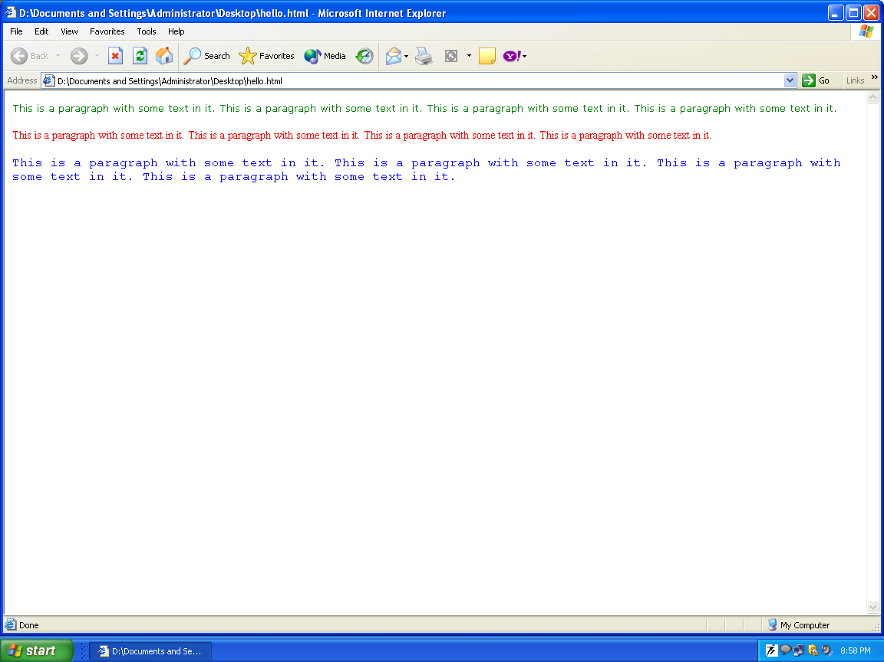

Similarly we can use style attribute in any other tag like in <body>, <h1>, etc. except in <font> tag.

Style attribute is mostly used for formatting the text.

LINK TAGS

Link tag is used to link one web page with another web page or file.

<a> & </a>

It is called as anchor tag which is used to create a link.

An anchor can point to any resource on the web: HTML page, an image, a sound file , a movie, etc.
The syntax of creating an anchor:
<a href="url">Text to be displayed</a>
The href Attribute
The href attribute is used to address the document to link to, and the words between the open and close of the anchor tag will be displayed as a hyperlink.
This anchor defines a link to www.mait.com:
<a href="http://www.mait.com/">it is our college!</a>

The Target Attribute
With the target attribute, you can define where the linked document will be opened.
The line below will open the document in a new browser window:
<a href="http://www.w3schools.com/"
target="_blank">Visit W3Schools!</a>

Basic Notes - Useful Tips
Always add a trailing slash to subfolder references. If you link like this: href="http://www.mait.com/html", you will generate two HTTP requests to the server, because the server will add a slash to the address and create a new request like this: href="http://www.mait.com/html/"
Named anchors are often used to create "table of contents" at the beginning of a large document. Each chapter within the document is given a named anchor, and links to each of these anchors are put at the top of the document.
If a browser cannot find a named anchor that has been specified, it goes to the top of the document. No error occurs.

Text written in notepad:

<a> tag and href attribute

<html>

<body>

hello world !

<a href="http://www.ipu.ac.in/"> please click here to open the university web site!!!!!!!!!!</a>

</body>

</html>

Browser window:
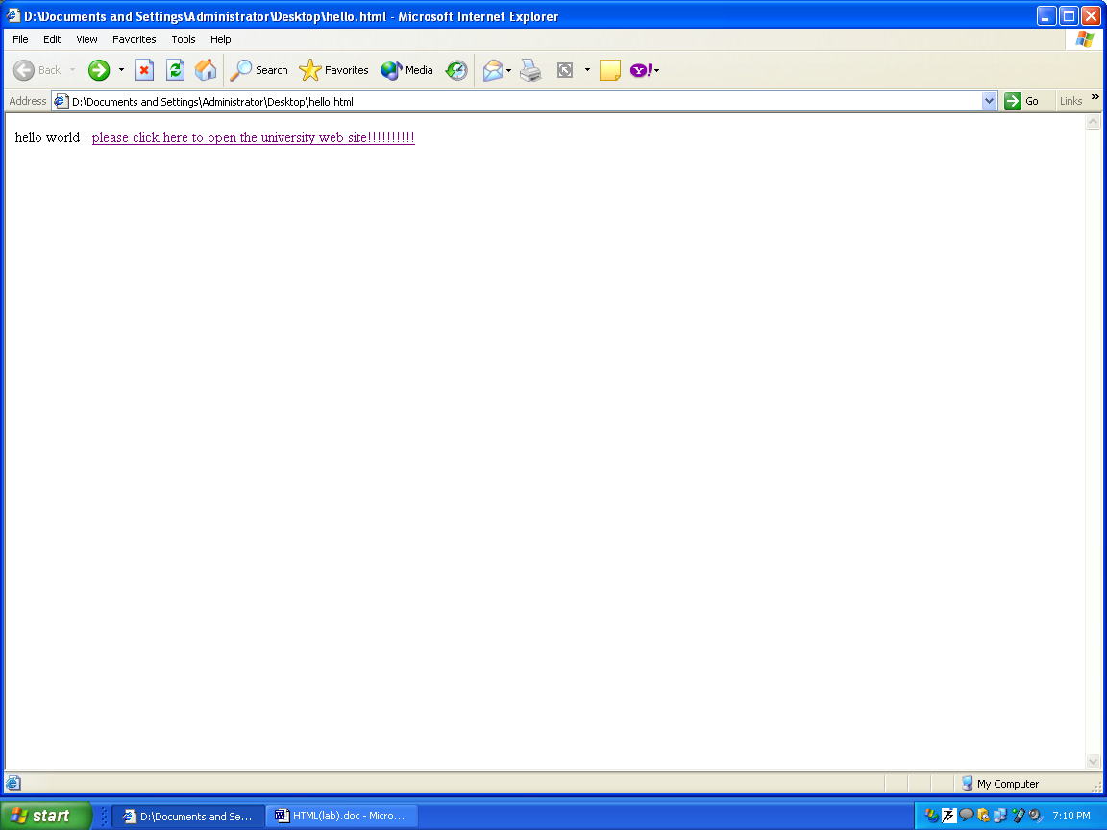

On clicking the above link the page will be opened on the same page by refreshing the previous page.

The page opened will be:

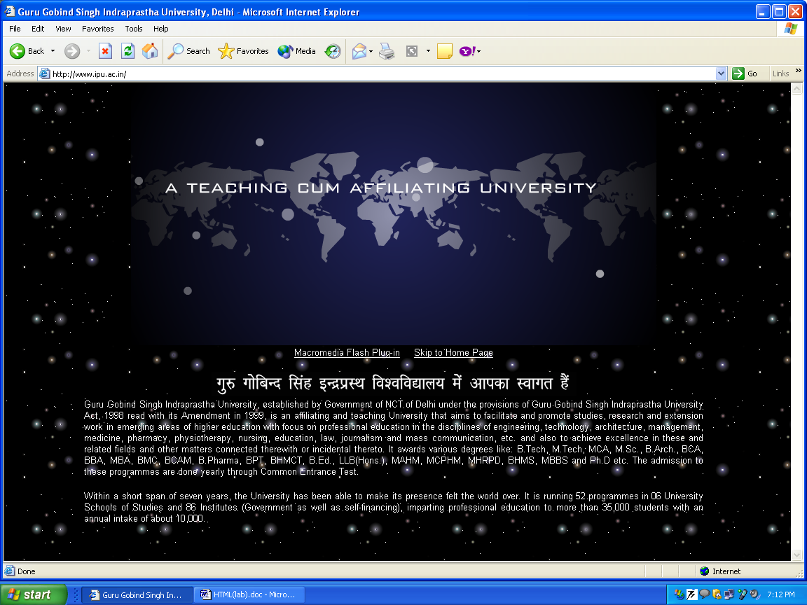

<a> tag and href attribute

Text written in notepad:

<html>

<body>

hello world !

<a href=http://www.ipu.ac.in/ target = “_blank”> please click here to open the university web site!!!!!!!!!!</a>

</body>

</html>

Browser window:

On clicking the above link the page will be opened on the other blank page without refreshing the previous page.

The page opened will be:

NOTE: To open any other file on clicking the link then write the
Address of that file as the value of the href attribute.

<frameset> tag
With frames, you can display more than one HTML document in the same browser window. Each HTML document is called a frame, and each frame is independent of the others.
The disadvantages of using frames are:
- The web developer must keep track of more HTML documents
- It is difficult to print the entire page

The Frameset Tag
- The <frameset> tag defines how to divide the window into frames
- Each frameset defines a set of rows or columns
- The values of the rows/columns indicate the amount of screen area each row/column will occupy

The Frame Tag
- The <frame> tag defines what HTML document to put into each frame
In the example below we have a frameset with two columns. The first column is set to 25% of the width of the browser window. The second column is set to 75% of the width of the browser window. The HTML document "frame_a.htm" is put into the first column, and the HTML document "frame_b.htm" is put into the second column:
<frameset cols="25%,75%">
<frame src="frame_a.htm">
<frame src="frame_b.htm">
</frameset>
NOTE: If a frame has visible borders, the user can resize it by dragging the border. To prevent a user from doing this, you can add noresize="noresize" to the <frame> tag.
Add the <noframes> tag for browsers that do not support frames.

Text written in notepad:

<html>

<frameset rows="50%,50%">

<frame src="test.html">

<frameset cols="25%,75%">

<frame src="test1.html">

<frame src="test2.html">

</frameset>

</frameset>

</html>

Browser window:

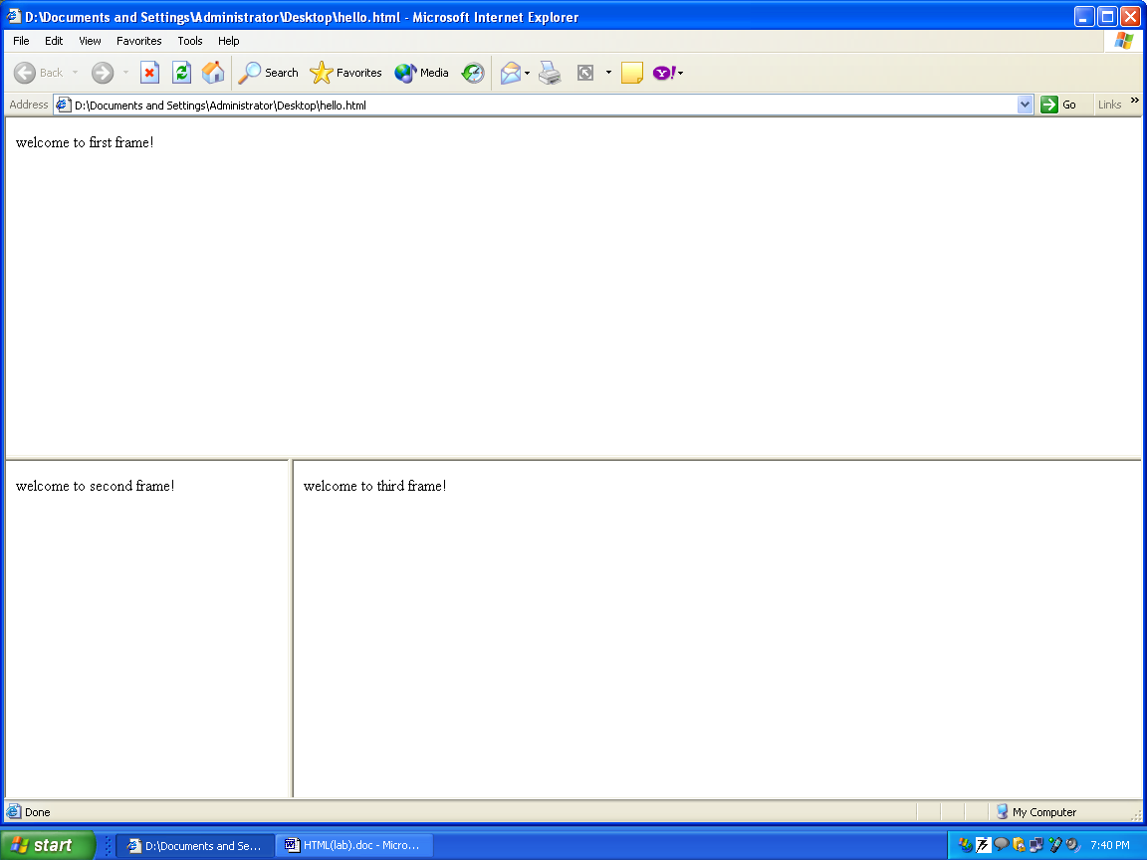

5. <table> tag
Tables are defined with the <table> tag. A table is divided into rows (with the <tr> tag), and each row is divided into data cells (with the <td> tag). The letters td stands for "table data," which is the content of a data cell. A data cell can contain text, images, lists, paragraphs, forms, horizontal rules, tables, etc.
<table border="1">
<tr>
<td>row 1, cell 1</td>
<td>row 1, cell 2</td>
</tr>
<tr>
<td>row 2, cell 1</td>
<td>row 2, cell 2</td>
</tr>
</table>
How it looks in a browser:
row 1, cell 1 | row 1, cell 2
row 2, cell 1 | row 2, cell 2

Tables and the Border Attribute
If you do not specify a border attribute the table will be displayed without any borders. Sometimes this can be useful, but most of the time, you want the borders to show.
To display a table with borders, you will have to use the border attribute:
<table border="1">
<tr>
<td>Row 1, cell 1</td>
<td>Row 1, cell 2</td>
</tr>
</table>

Headings in a Table
Headings in a table are defined with the <th> tag.
<table border="1">
<tr>
<th>Heading</th>
<th>Another Heading</th>
</tr>
<tr>
<td>row 1, cell 1</td>
<td>row 1, cell 2</td>
</tr>
<tr>
<td>row 2, cell 1</td>
<td>row 2, cell 2</td>
</tr>
</table>
How it looks in a browser:
Heading | Another Heading
row 1, cell 1 | row 1, cell 2
row 2, cell 1 | row 2, cell 2

Empty Cells in a Table
Table cells with no content are not displayed very well in most browsers.
<table border="1">
<tr>
<td>row 1, cell 1</td>
<td>row 1, cell 2</td>
</tr>
<tr>
<td>row 2, cell 1</td>
<td></td>
</tr>
</table>
How it looks in a browser:
row 1, cell 1 | row 1, cell 2
row 2, cell 1
Note that the borders around the empty table cell are missing (NB! Mozilla Firefox displays the border).
To avoid this, add a non-breaking space (&nbsp;) to empty data cells, to make the borders visible:
<table border="1">
<tr>
<td>row 1, cell 1</td>
<td>row 1, cell 2</td>
</tr>
<tr>
<td>row 2, cell 1</td>
<td>&nbsp;</td>
</tr>
</table>
How it looks in a browser:
row 1, cell 1 | row 1, cell 2
row 2, cell 1

Few examples:

Table with no border

Text written in notepad:

<html>

<body>

<h4>This table has no borders:</h4>

<table>

<tr>

<td>100</td>

<td>200</td>

<td>300</td>

</tr>

<tr>

<td>400</td>

<td>500</td>

<td>600</td>

</tr>

</table>

<h4>And this table has no borders:</h4>

<table border="0">

<tr>

<td>100</td>

<td>200</td>

<td>300</td>

</tr>

<tr>

<td>400</td>

<td>500</td>

<td>600</td>

</tr>

</table></body>

</html>

browser window

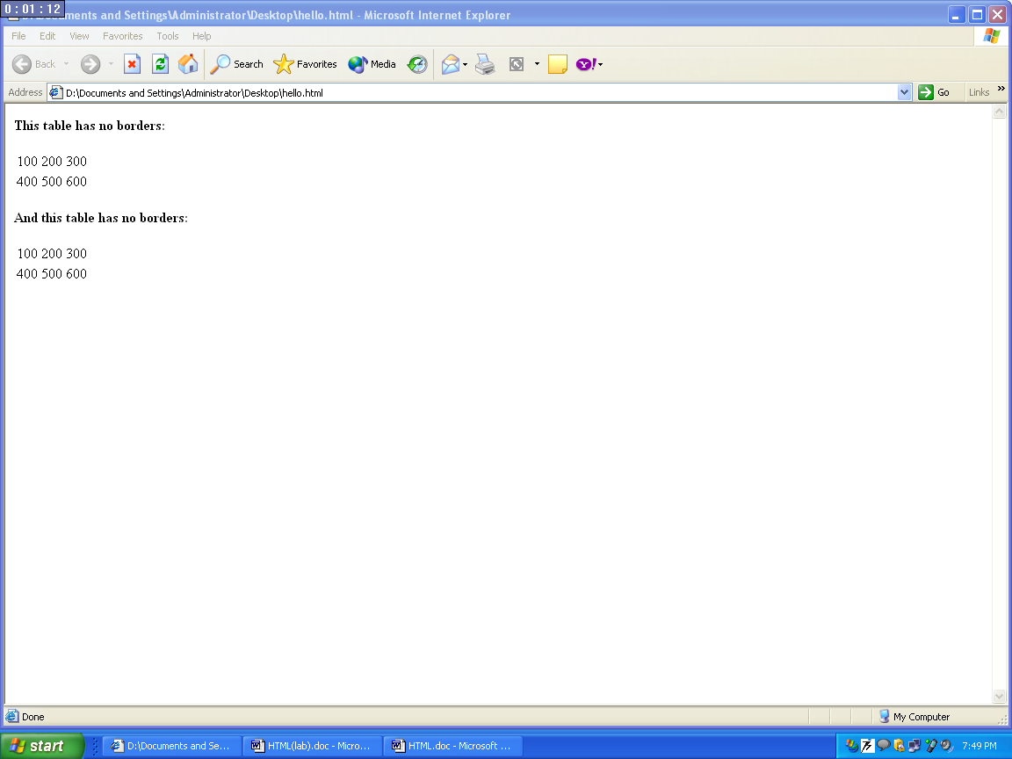

Headings in the table

Text written in notepad:

<html>

<body>

<h4>Table headers:</h4>

<table border="1">

<tr>

<th>Name</th>

<th>Telephone</th>

<th>Telephone</th>

</tr>

<tr>

<td>Bill Gates</td>

<td>555 77 854</td>

<td>555 77 855</td>

</tr>

</table>

<h4>Vertical headers:</h4>

<table border="1">

<tr>

<th>First Name:</th>

<td>Bill Gates</td>

</tr>

<tr>

<th>Telephone:</th>

<td>555 77 854</td>

</tr>

<tr>

<th>Telephone:</th>

<td>555 77 855</td>

</tr></table><body></html>

browser window:

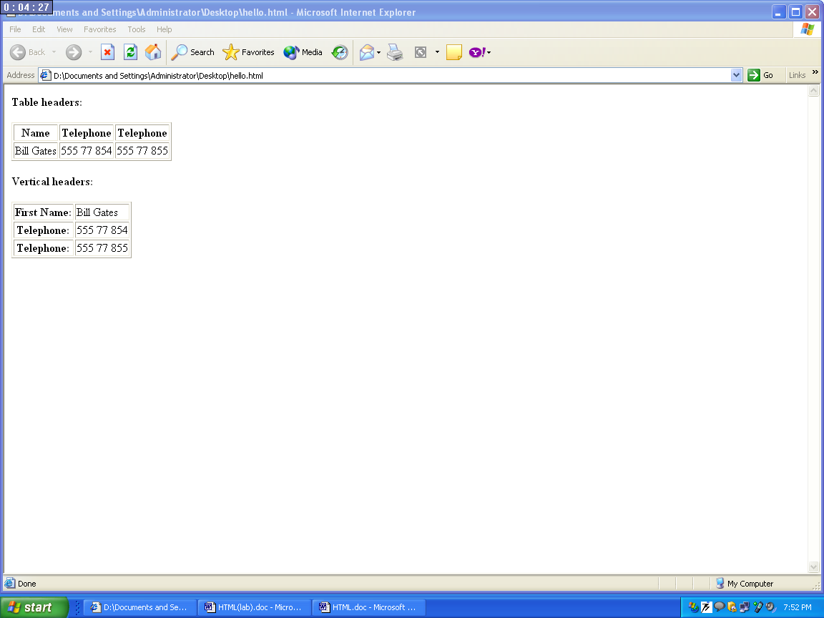

Empty cell in the table

Text written in notepad:

<html>

<body>

<table border="1">

<tr>

<td>Some text</td>

<td>Some text</td>

</tr>

<tr>

<td></td>

<td>Some text</td>

</tr>

</table>

<p>

As you can see, one of the cells has no border. That is because it is empty. Try to insert a space in the cell. Still it has no border.

</p>

<p>

The trick is to insert a no-breaking space in the cell.

</p>

<p>No-breaking space is a character entity. If you don't know what a character entity is, read the chapter about it.

</p>

<p>The no-breaking space entity starts with an ampersand ("&"),

then the letters "nbsp", and ends with a semicolon (";")

</p>

</body>

</html>

Browser window:

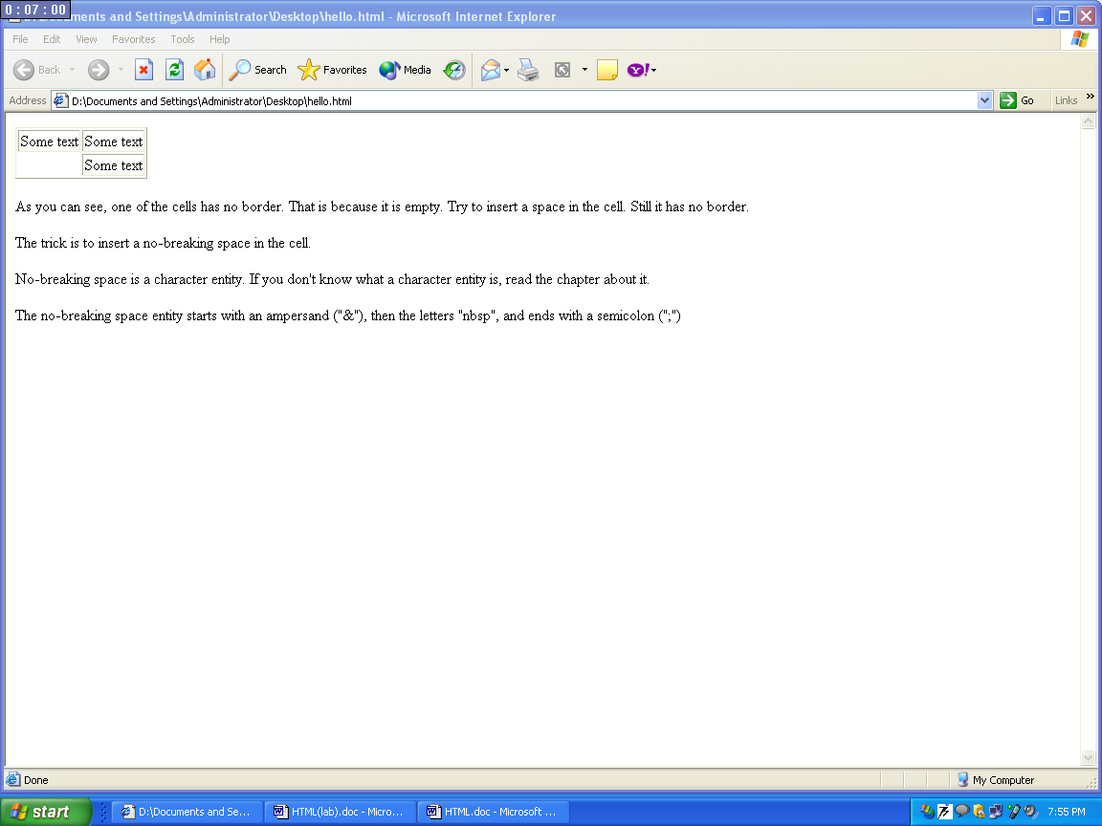

<list> tag

There are three types of lists defined in HTML.

Ordered list

Unordered list

Definition list

Ordered Lists
An ordered list is also a list of items. The list items are marked with numbers.
An ordered list starts with the <ol> tag. Each list item starts with the <li> tag.
<ol>
<li>Coffee</li>
<li>Milk</li>
</ol>
Here is how it looks in a browser:
- Coffee
- Milk
Inside a list item you can put paragraphs, line breaks, images, links, other lists, etc.

Unordered Lists
An unordered list is a list of items. The list items are marked with bullets (typically small black circles).
An unordered list starts with the <ul> tag. Each list item starts with the <li> tag.
<ul>
<li>Coffee</li>
<li>Milk</li>
</ul>
Here is how it looks in a browser:
- Coffee
- Milk
Inside a list item you can put paragraphs, line breaks, images, links, other lists, etc.

Definition Lists
A definition list is not a list of items. This is a list of terms and explanation of the terms.
A definition list starts with the <dl> tag. Each definition-list term starts with the <dt> tag. Each definition-list definition starts with the <dd> tag.
<dl>
<dt>Coffee</dt>
<dd>Black hot drink</dd>
<dt>Milk</dt>
<dd>White cold drink</dd>
</dl>
Here is how it looks in a browser:
Coffee
Black hot drink
Milk
White cold drink
Inside a definition-list definition (the <dd> tag) you can put paragraphs, line breaks, images, links, other lists, etc.

EXAMPLES :

ORDERED LIST

Text written in the notepad:

<html>

<body>

<h4>Numbered list:</h4>

<ol>

<li>Apples</li>

<li>Bananas</li>

<li>Lemons</li>

<li>Oranges</li>

</ol>

<h4>Letters list:</h4>

<ol type="A">

<li>Apples</li>

<li>Bananas</li>

<li>Lemons</li>

<li>Oranges</li>

</ol>

<h4>Lowercase letters list:</h4>

<ol type="a">

<li>Apples</li>

<li>Bananas</li>

<li>Lemons</li>

<li>Oranges</li>

</ol>

<h4>Roman numbers list:</h4>

<ol type="I">

<li>Apples</li>

<li>Bananas</li>

<li>Lemons</li>

<li>Oranges</li>

</ol>

<h4>Lowercase Roman numbers list:</h4>

<ol type="i">

<li>Apples</li>

<li>Bananas</li>

<li>Lemons</li>

<li>Oranges</li>

</ol>

</body>

</html>

Browser window:

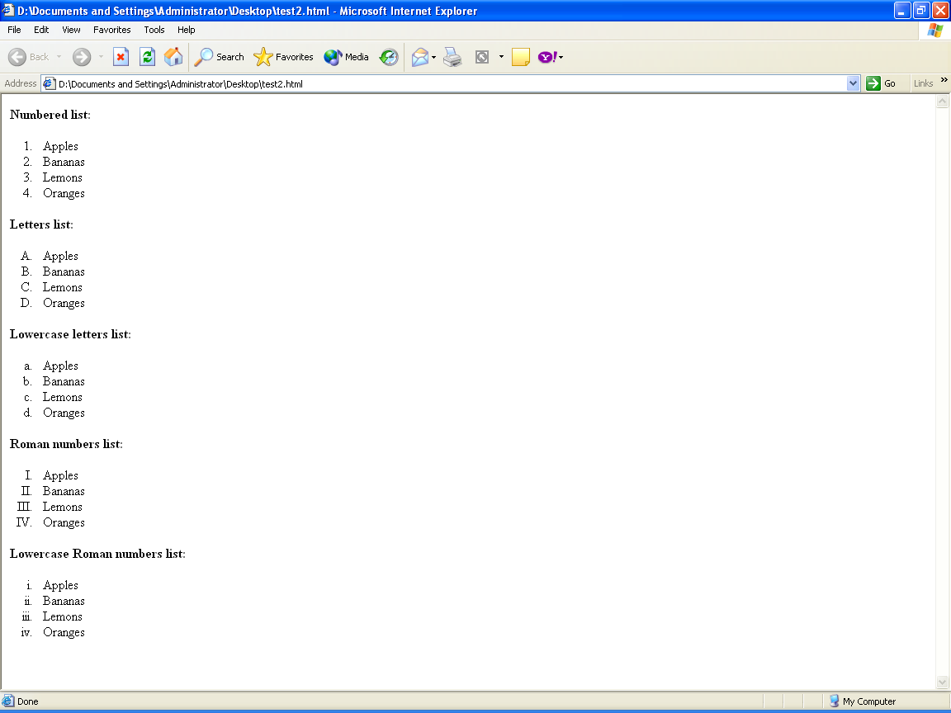

UNORDERED LIST

Text written in notepad:

<html>

<body>

<h4>Disc bullets list:</h4>

<ul type="disc">

<li>Apples</li>

<li>Bananas</li>

<li>Lemons</li>

<li>Oranges</li>

</ul>

<h4>Circle bullets list:</h4>

<ul type="circle">

<li>Apples</li>

<li>Bananas</li>

<li>Lemons</li>

<li>Oranges</li>

</ul>

<h4>Square bullets list:</h4>

<ul type="square">

<li>Apples</li>

<li>Bananas</li>

<li>Lemons</li>

<li>Oranges</li>

</ul>

</body>

</html>

Browser Window:

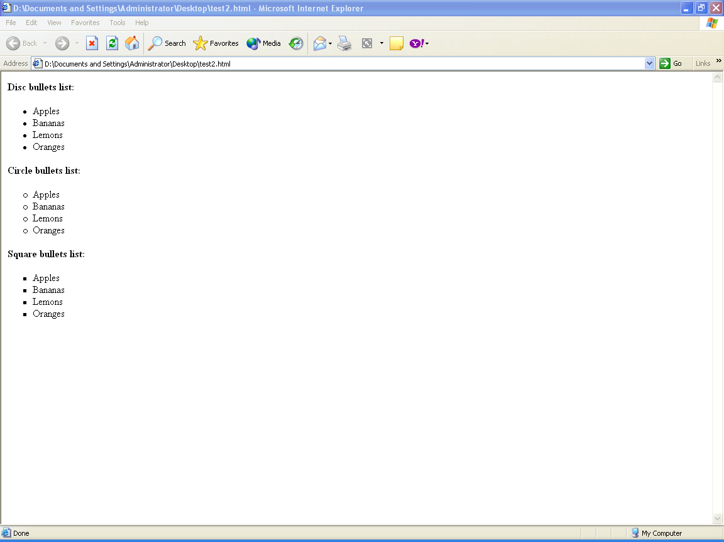

DEFINITION LIST

Text written in notepad:

<html>

<body>

<h4>A Definition List:</h4>

<dl>

<dt>Coffee</dt>

<dd>Black hot drink</dd>

<dt>Milk</dt>

<dd>White cold drink</dd>

</dl>

</body>

</html>

Browser Window:

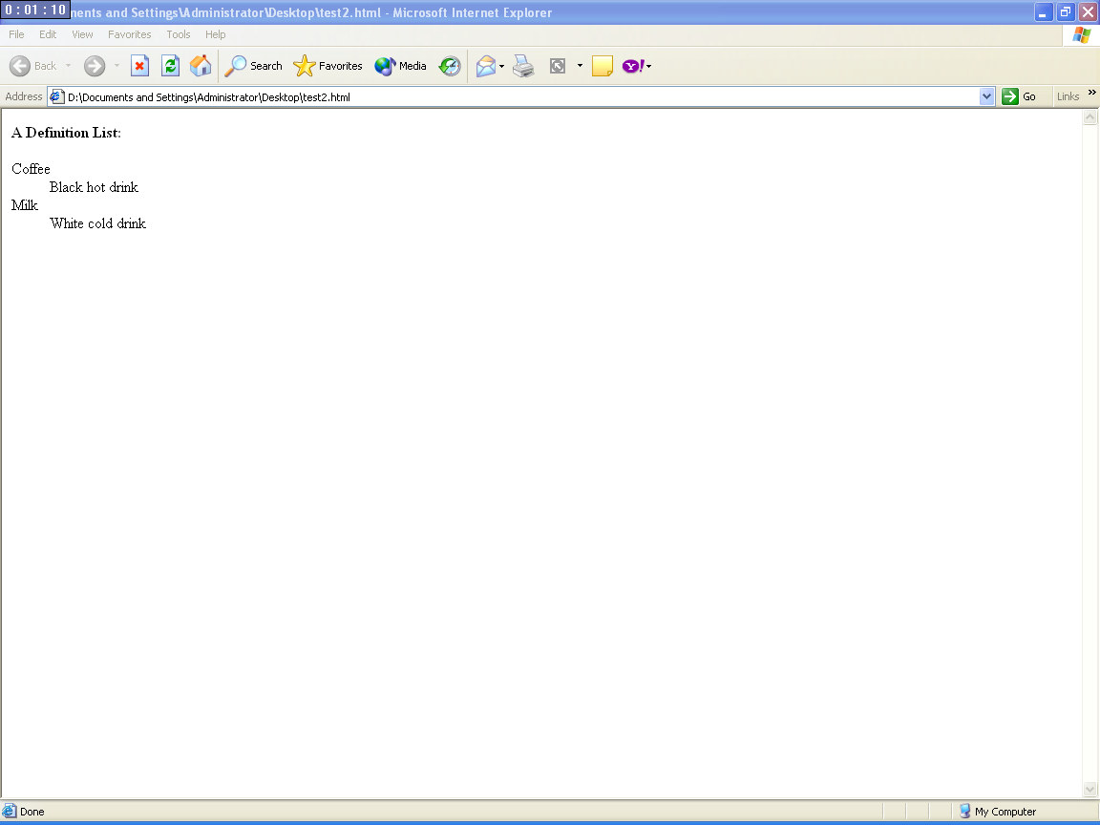

NESTED LIST

Text written in notepad:

<html>

<body>

<h4>A nested List:</h4>

<ul>

<li>Coffee</li>

<li>Tea

<ul>

<li>Black tea</li>

<li>Green tea

<ul>

<li>China</li>

<li>Africa</li>

</ul>

</li>

</ul>

</li>

<li>Milk</li>

</ul>

</body>

</html>

Browser Window:

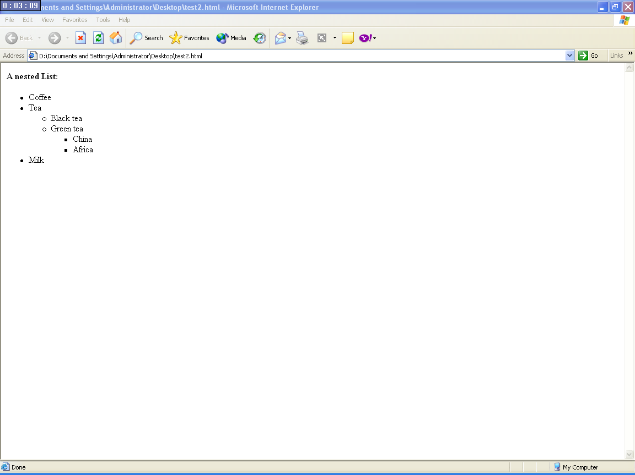

<form> tag

A form is an area that can contain form elements.
Form elements are elements that allow the user to enter information (like text fields, textarea fields, drop-down menus, radio buttons, checkboxes, etc.) in a form.
A form is defined with the <form> tag.
<form>
<input>
<input>
</form>

Input
The most used form tag is the <input> tag. The type of input is specified with the type attribute. The most commonly used input types are explained below.

Text Fields
Text fields are used when you want the user to type letters, numbers, etc. in a form.
<form>
First name:
<input type="text" name="firstname">
<br>
Last name:
<input type="text" name="lastname">
</form>
How it looks in a browser:
Top of Form
First name: 
Last name:
Bottom of Form
Note that the form itself is not visible. Also note that in most browsers, the width of the text field is 20 characters by default.

Radio Buttons
Radio Buttons are used when you want the user to select one of a limited number of choices.
<form>
<input type="radio" name="sex" value="male"> Male
<br>
<input type="radio" name="sex" value="female"> Female
</form>
How it looks in a browser:
Top of Form
Male
Female
Bottom of Form
Note that only one option can be chosen.

Checkboxes
Checkboxes are used when you want the user to select one or more options of a limited number of choices.
<form>
<input type="checkbox" name="bike">
I have a bike
<br>
<input type="checkbox" name="car">
I have a car
</form>
How it looks in a browser:
Top of Form
I have a bike
I have a car
Bottom of Form

The Form's Action Attribute and the Submit Button
When the user clicks on the "Submit" button, the content of the form is sent to another file. The form's action attribute defines the name of the file to send the content to. The file defined in the action attribute usually does something with the received input.
<form name="input" action="html_form_action.asp"
method="get">
Username:
<input type="text" name="user">
<input type="submit" value="Submit">
</form>
How it looks in a browser:
Top of Form
Username: 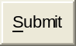
Bottom of Form
If you type some characters in the text field above, and click the "Submit" button, you will send your input to a page called "html_form_action.asp". That page will show you the received input.

EXAMPLES

Checkboxes

Text written in notepad:
<html>
<body>
<form>
I have a bike:
<input type="checkbox" name="Bike">
<br>
I have a car:
<input type="checkbox" name="Car">
</form>
</body>
</html>
Browser window:
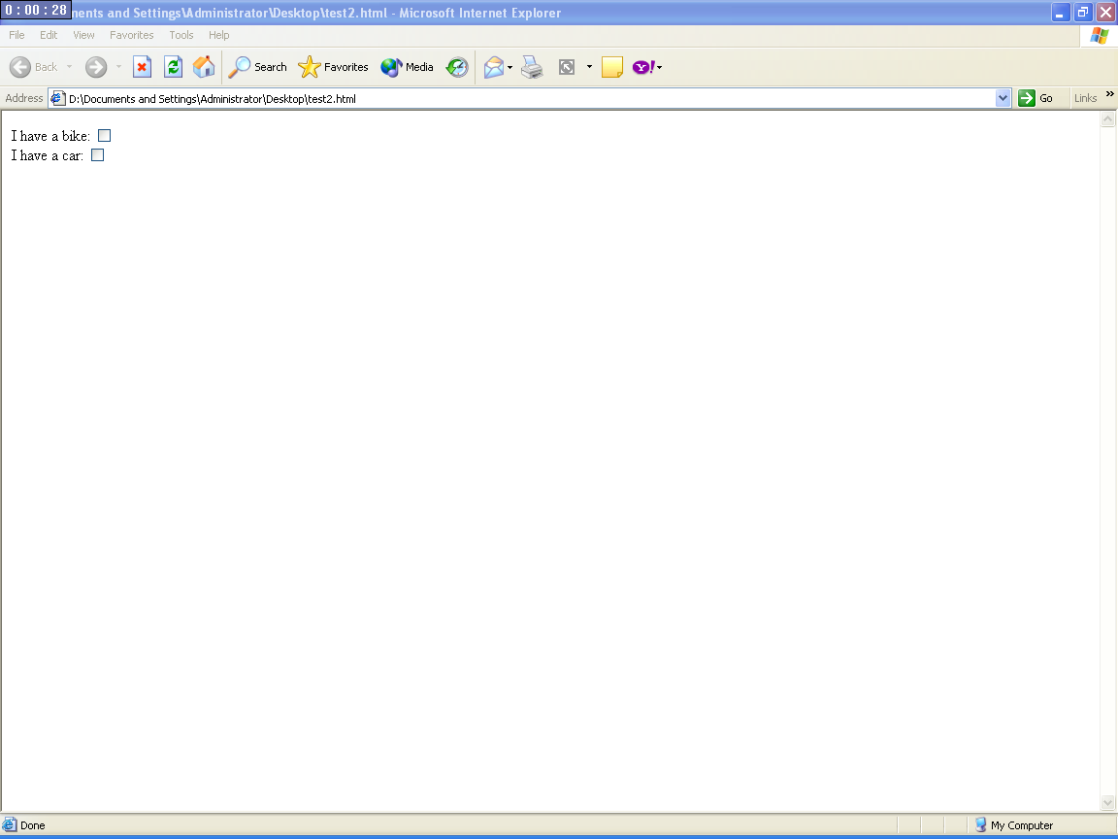

Radio button

Text written in notepad:
<html>
<body>
<form>
I have a bike:
<input type="radio" name="Bike">
<br>
I have a car:
<input type="radio" name="Car">
</form>
</body></html>
Browser window:
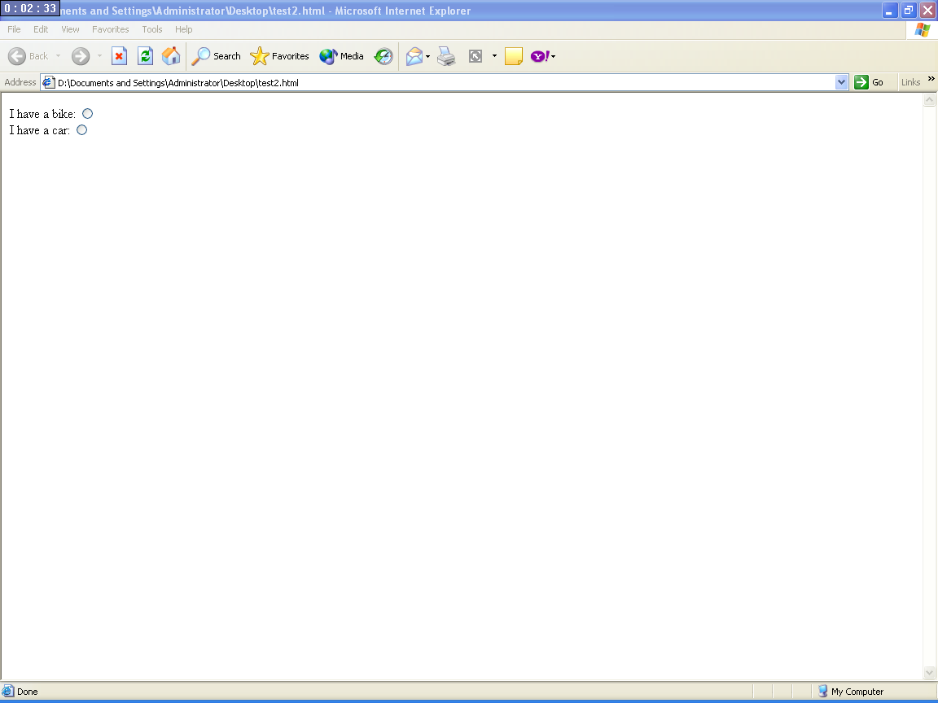

Drop Down box

Text written in notepad:
<html>
<body>
<form>
<select name="cars">
<option value="volvo">Volvo
<option value="saab">Saab
<option value="fiat">Fiat
<option value="audi">Audio </select></form></body></html>
Browser Window:
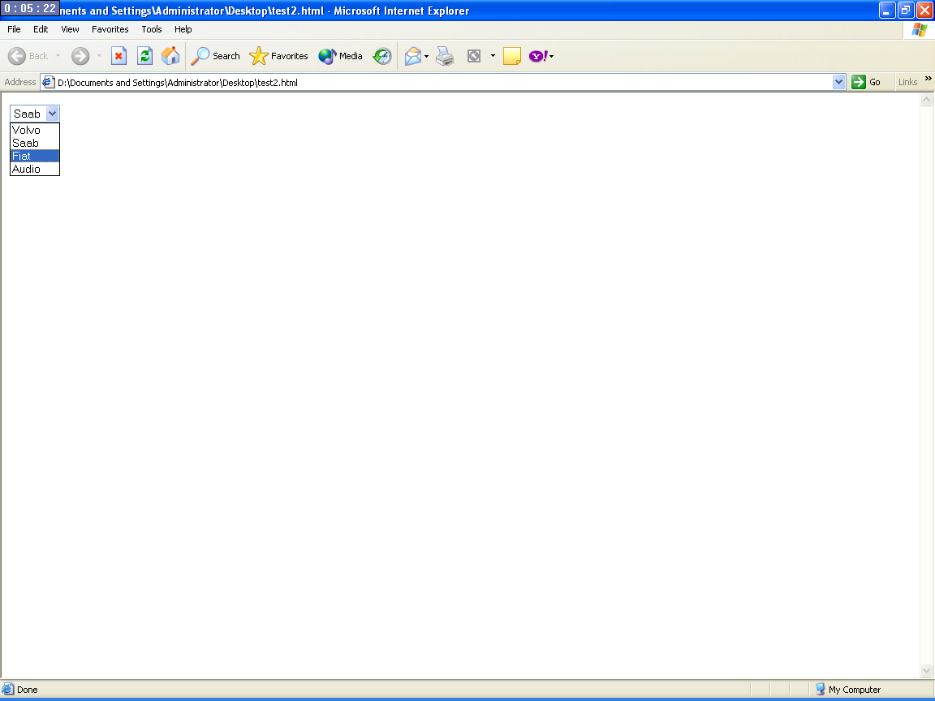

Creating a text area

Text written in notepad:
<html>
<body>
hello world ! you can type anything in the box below……………
<br>
<textarea rows = “10” cols=”30”>
using HTML we can create various web pages and also different frames!
</textarea>
</body>
</html>

Browser Window:
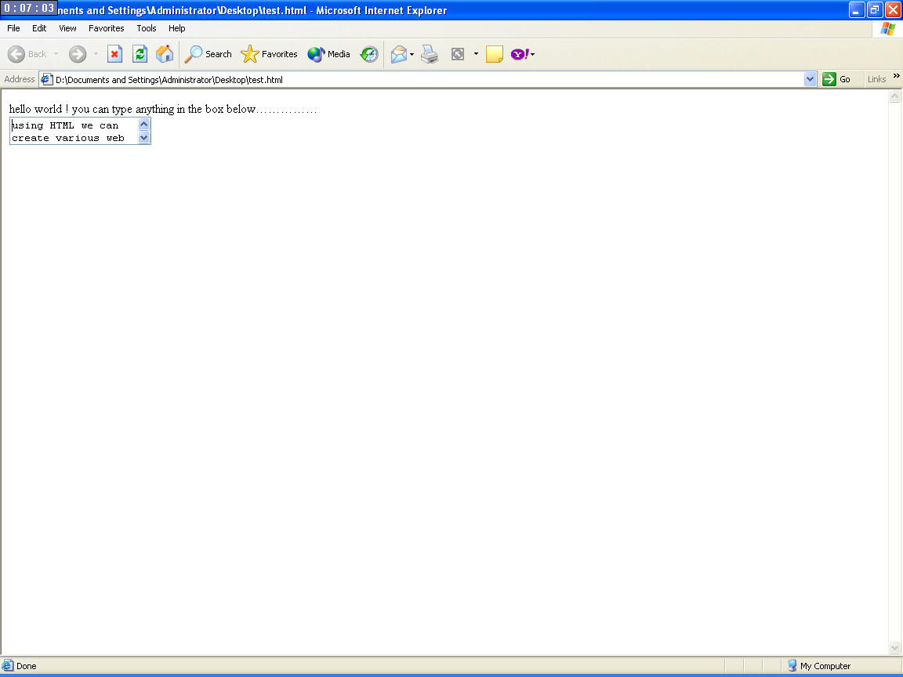

Creating a password field

Text written in notepad:

<html>

<body>

<form>

Username:

<input type="text" name="user">

<br>

Password:

<input type="password" name="password">

</form>

<p>

Note that when you type characters in a password field, the browser displays asterisks or bullets instead of the characters.

</p></body></html>

Browser Window:

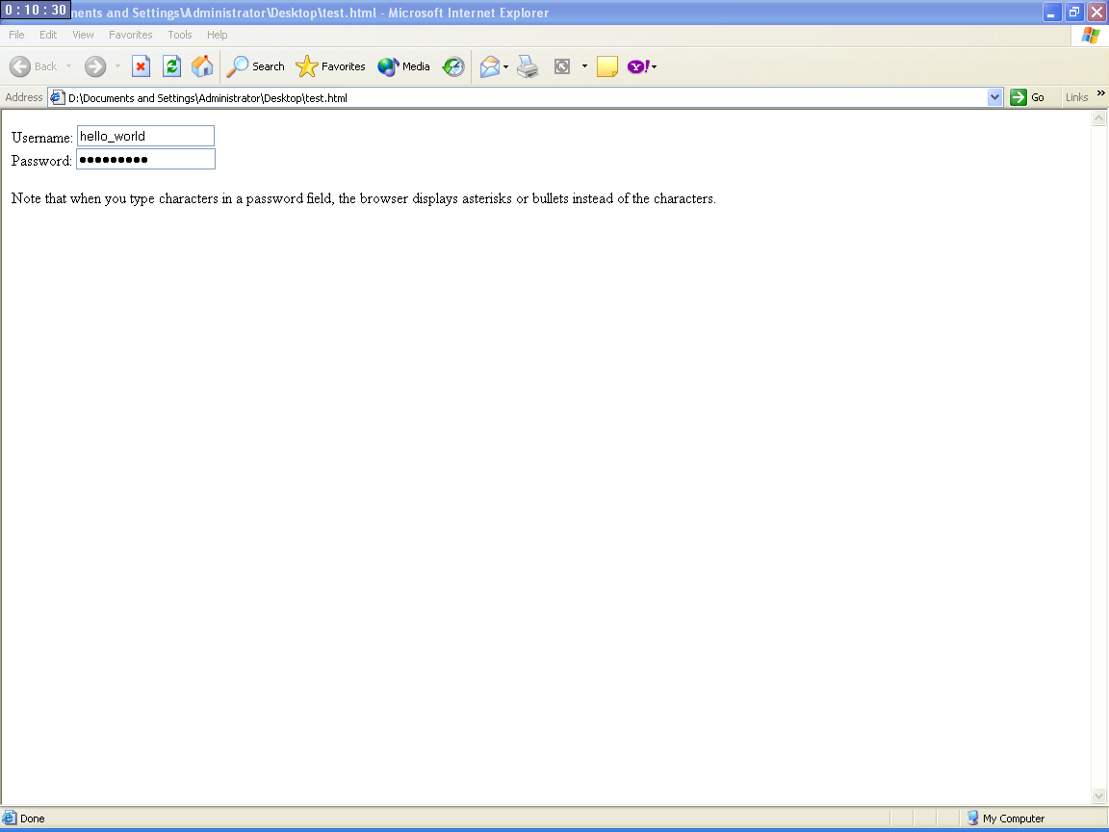

<img> tag

<img> tag is used to open images in the HTML page.
The <img> tag is empty, which means that it contains attributes only and it has no closing tag.
To display an image on a page, you need to use the src attribute. Src stands for "source". The value of the src attribute is the URL of the image you want to display on your page.
The syntax of defining an image:
<img src="url">
The URL points to the location where the image is stored. An image named "boat.gif" located in the directory "images" on "www.ggsipu.com" has the URL: http://www.ggsipu.com/images/boat.gif.
The browser puts the image where the image tag occurs in the document. If you put an image tag between two paragraphs, the browser shows the first paragraph, then the image, and then the second paragraph.
Suppose there is an image in drive C:/folder/photo.jpg then the full path is written in place of url.

EXAMPLES

Opening an image in the background

Text written in notepad:

<html>

<body>

<p>

An image:

<img src="D:\wallpapers\nature\Water lilies.jpg"

width="144" height="50">

</p>

<p>

A moving image:

<img src="D:\wallpapers\nature\WO_SCN10.JPG"

width="48" height="48">

</p>

<p>

Note that the syntax of inserting a moving image is no different from that of a non-moving image.

</p>

</body>

</html>

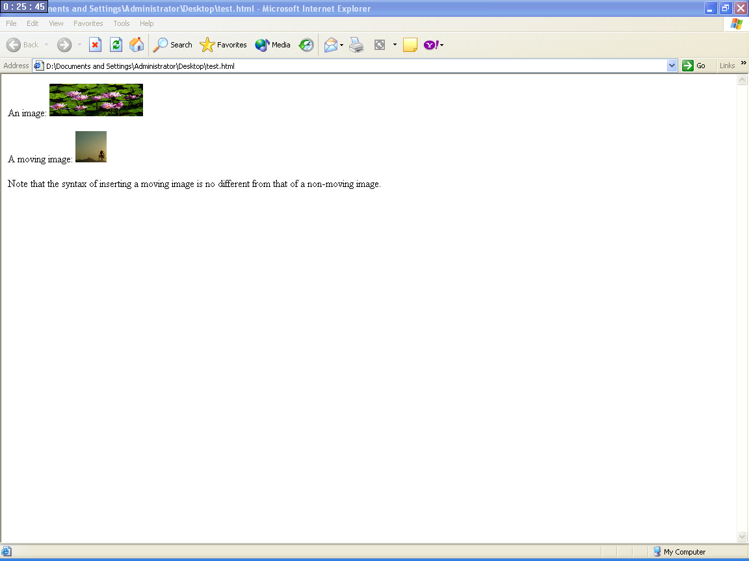

Making an image as a hyperlink.

Text written in notepad:

<html>

<body>

<p>

You can also use an image as a link:

<a href="lastpage.htm">

<img border="0" src="buttonnext.gif" width="65" height="38">

</a>

</p>

</body>

</html>

Browser window:

You can also use an image as a link: 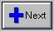

Browser window after clicking on the link:

Congratulations !
You have reached the last page on the Internet. We hope that you have enjoyed surfing the Web.
Now there is really nothing more to see. You can safely turn off your computer, and come back to life.

Changing of background

Backgrounds
The <body> tag has two attributes where you can specify backgrounds. The background can be a color or an image.

Bgcolor
The bgcolor attribute sets the background to a color. The value of this attribute can be a hexadecimal number, an RGB value, or a color name.
<body bgcolor="#000000">
<body bgcolor="rgb(0,0,0)">
<body bgcolor="black">
The lines above all set the background color to black.

Background
The background attribute sets the background to an image. The value of this attribute is the URL of the image you want to use. If the image is smaller than the browser window, the image will repeat itself until it fills the entire browser window.
<body background="clouds.gif">
<body background="http://www.w3schools.com/clouds.gif">
The URL can be relative (as in the first line above) or absolute (as in the second line above).
Note: If you want to use a background image, you should keep in mind:
- Will the background image increase the loading time too much? Tip: Image files should be maximum 10k
- Will the background image look good with other images on the page?
- Will the background image look good with the text colors on the page?
- Will the background image look good when it is repeated on the page?

EXAMPLES

Opening an image in the background

Text written in notepad:

<html>

<body background="D:\wallpapers\nature\BOREALIS.JPG">

<h3>Image Background</h3>

<p>Both gif and jpg files can be used as HTML backgrounds.</p>

<p>If the image is smaller than the page, the image will repeat itself.</p>

</body>

</html>

Browser window:

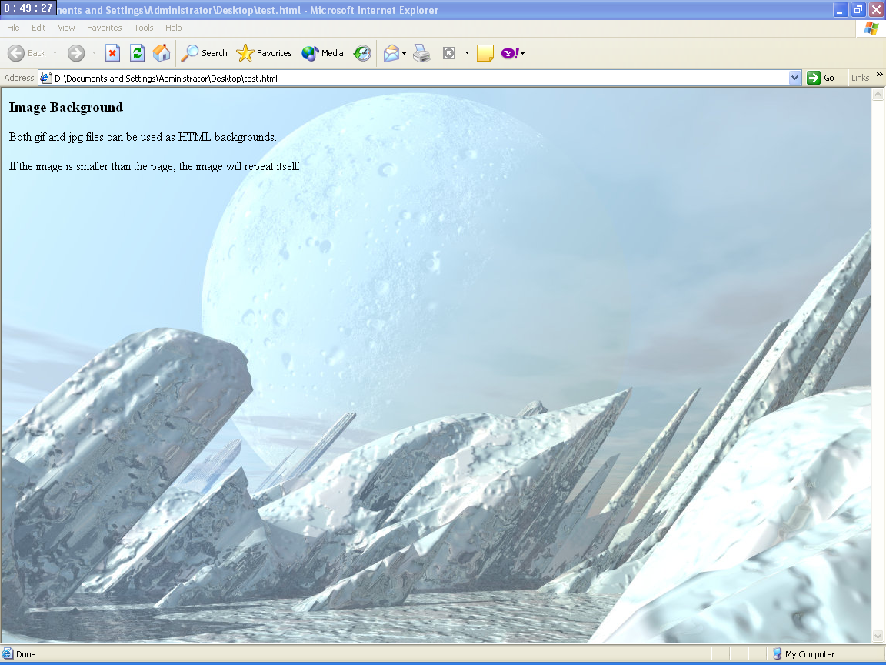

changing the color of the background

Text written in notepad:

<html>

<body bgcolor="light blue">

<h3>Background is changed </h3>

</body>

</html>

Browser window:

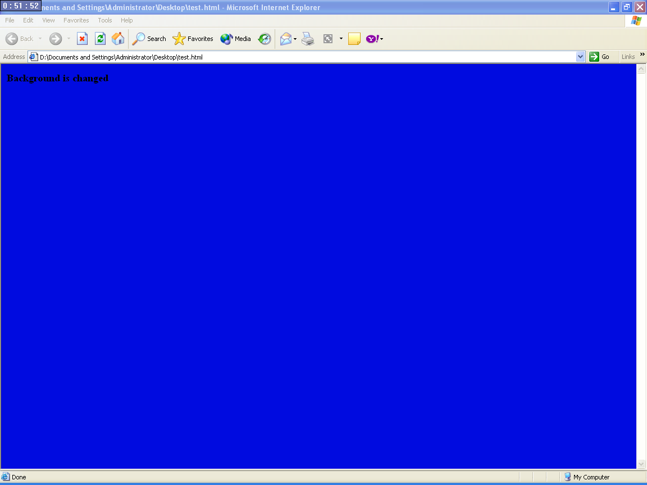

ALL THE TAGS USED IN HTML CAN BE SUMMARISED IN THE FORM OF TABLES

BASIC TAGS
Tag | Description
<html> | Defines an HTML document
<body> | Defines the document's body
<h1> to <h6> | Defines header 1 to header 6
<p> | Defines a paragraph
<br> | Inserts a single line break
<hr> | Defines a horizontal rule
<!--> | Defines a comment

TEXT FORMATTING TAGS
Tag | Description
<b> | Defines bold text
<big> | Defines big text
<em> | Defines emphasized text
<i> | Defines italic text
<small> | Defines small text
<strong> | Defines strong text
<sub> | Defines subscripted text
<sup> | Defines superscripted text
<ins> | Defines inserted text
<del> | Defines deleted text

LINK TAGS
Tag | Description
<a> | Defines an anchor

FRAME TAGS
Tag | Description
<frameset> | Defines a set of frames
<frame> | Defines a sub window (a frame)
<noframes> | Defines a noframe section for browsers that do not handle frames
<iframe> | Defines an inline sub window (frame)

TABLE TAGS
Tag | Description
<table> | Defines a table
<th> | Defines a table header
<tr> | Defines a table row
<td> | Defines a table cell
<caption> | Defines a table caption
<colgroup> | Defines groups of table columns
<col> | Defines the attribute values for one or more columns in a table
<thead> | Defines a table head
<tbody> | Defines a table body
<tfoot> | Defines a table footer

LIST TAGS
Tag | Description
<ol> | Defines an ordered list
<ul> | Defines an unordered list
<li> | Defines a list item
<dl> | Defines a definition list
<dt> | Defines a definition term
<dd> | Defines a definition description
<dir> | Deprecated. Use <ul> instead
<menu> | Deprecated. Use <ul> instead

FORM TAGS
Tag | Description
<form> | Defines a form for user input
<input> | Defines an input field
<textarea> | Defines a text-area (a multi-line text input control)
<label> | Defines a label to a control
<fieldset> | Defines a fieldset
<legend> | Defines a caption for a fieldset
<select> | Defines a selectable list (a drop-down box)
<optgroup> | Defines an option group
<option> | Defines an option in the drop-down box
<button> | Defines a push button
<isindex> | Deprecated. Use <input> instead

IMAGE TAGS
Tag | Description
<img> | Defines an image
<map> | Defines an image map
<area> | Defines an area inside an image map

MOVING TAGS
Tag | Description
<marquee> | Moves element b/wthe tags

Useful Tips for making a web page using HTML
When you write HTML text, you can never be sure how the text is displayed in another browser. Some people have large computer displays, some have small. The text will be reformatted every time the user resizes his window. Never try to format the text in your editor by adding empty lines and spaces to the text.
HTML will truncate the spaces in your text. Any number of spaces counts as one. Some extra information: In HTML a new line counts as one space.
Using empty paragraphs <p> to insert blank lines is a bad habit. Use the <br> tag instead. (But don't use the <br> tag to create lists. Wait until you have learned about HTML lists.)
You might have noticed that paragraphs can be written without the closing tag </p>. Don't rely on it. The next version of HTML will not allow you to skip ANY closing tags.
HTML automatically adds an extra blank line before and after some elements, like before and after a paragraph, and before and after a heading.
As seen in the above examples, by using various tags of HTML we can create web pages of are choice.

VIVA QUESTIONS
- What is HTML?
- What are the basic building blocks for HMTL?
- What do u understand by the terms tags & elements?
- How can we change the background of the web page?
- How can the font of the text be changed? List all the methods.
- What is the extension of an HTML file?
- Why is the HTML document written in a note pad?
- List few of the text formatting tags.
- Give the name of the tag and the attribute used to create hyperlinks.
- What do you understand by the term attribute?

EXPERIMENTS TO PERFORM
  - Use HTML to design a home page for IGIT using all the features of HTML.
    - Make a web page of a medical company indicating all the details and products of that company.
    - Make a feedback form for any T.V serial shown on the television.
    - Make a web page of an advertising company using all the tags of HTML.
  - a) Create a web page containing hyperlinks to the pages having information about Science and Technology.
b) Make a web page for the college library. The page should contain hyperlinks for the books available in the library. Clicking on those links should open the details of that respective book. Details of the book should contain Author of the book, subject for which it is used and whether that book is issued or not.

